Home Automation System



©HappyHome 1.0

*All rights reserved.*

**Technical Specification**

Table of Contents

1. Introduction 2

2. Hardware Specification 2

Raspberry Pi 3 model B 2

NodeMCU 1.0 2

DHT22 temperature and humidity sensor 2

Rain detecting Sensor 2

PIR motion sensor 2

Relay switches 2

Logical level converters 2

15W solar panel 2

Voltage regulators 2

Water level sensor 2

Solenoid water valves 2

Soil moisture sensor 2

Vibrations detecting sensor 2

Photocell light sensitive model 2

3. Software Specification 3

4. Segments 3

4.1. Living Room 3

4.2. Garden 3

4.3. Kitchen 3

# Introduction

In Happy Home 1.0 there are three static segments, Living Room, Garden and Kitchen. In those segments we have covered almost all home appliances. This mannual is included all hardware and software related specifications and datasheets for hardware parts.

# Hardware Specification

In this section, it is stated all the hardware parts used for **HappyHome1.0** and their datasheets. Before using the system we strongly advice users to read this datasheets and have a better understanding on interaction of hardware components and also to follow these instructions.

## Raspberry Pi 3 model B

## NodeMCU 1.0

## DHT22 temperature and humidity sensor

## Rain detecting Sensor

## PIR motion sensor

## Relay switches

## Logical level converters

## 15W solar panel

## Voltage regulators

## Water level sensor

## Solenoid water valves

## Soil moisture sensor

## Vibrations detecting sensor

## Photocell light sensitive model

# Software Specification

# Segments

## Living Room

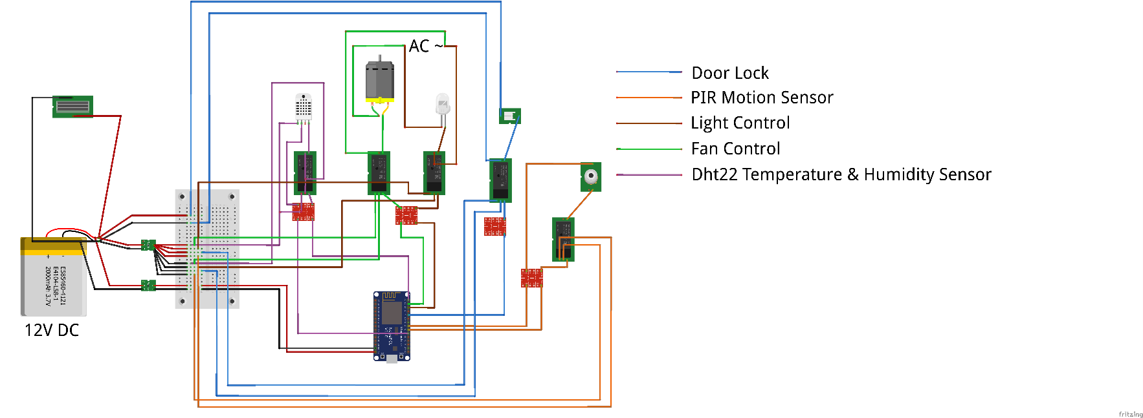

*Figure 1*

## Garden

## Kitchen